**General Chemistry LabII-1112L**

Lab 2: Gas Laws

Objective: Explore the relationship between volume and pressure of a gas through the experimentation of decreasing the volume of a gas in a syringe.

Procedure:

1. First, we connected everything necessary. The Luer-lock syringe was pulled out as much as possible and then connected to the gas pressure sensor, which was then connected to the LabQuest instrument.
2. On my paper, I drew out a chart similar to that in the lab manual, containing columns to record the number, volume and pressure, and the constant (the two numbers multiplied).
3. We then calibrated the LabQuest to get our desired unit, atm, then we began the experiment.
4. To begin, we recorded the initial volume, 20 mL, and the initial pressure, 0.986 atm. We then went down by 1 mL increments, recording the pressure at every mL until we could no longer go down, so our experiment ended with a volume of 9.0 mL. The entire chart can be seen below.

Results 1:

|  |  |  |  |
| --- | --- | --- | --- |
| # | Vsyringe mL | Psystem  atm | Psystem Vsyringe mL * atm |
| 1 | 20.0 | 0.986 | 20 * 0.986 = 19.72 |
| 2 | 19.0 | 1.037 | 19 * 1.037= 19.703 |
| 3 | 18.0 | 1.084 | 18 * 1.084= 19.512 |
| 4 | 17.0 | 1.146 | 17 * 1.146= 19.482 |
| 5 | 16.0 | 1.213 | 16 * 1.213= 19.408 |
| 6 | 15.0 | 1.278 | 15 * 1.278= 19.17 |
| 7 | 14.0 | 1.351 | 14 * 1.351= 18.914 |
| 8 | 13.0 | 1.456 | 13 * 1.456= 18.928 |
| 9 | 12.0 | 1.558 | 12 * 1.558= 18.696 |
| 10 | 11.0 | 1.675 | 11 * 1.675= 18.425 |
| 11 | 10.0 | 1.805 | 10 * 1.805= 18.05 |
| 12 | 9.00 | 2.000 | 9 * 2.000= 18 |

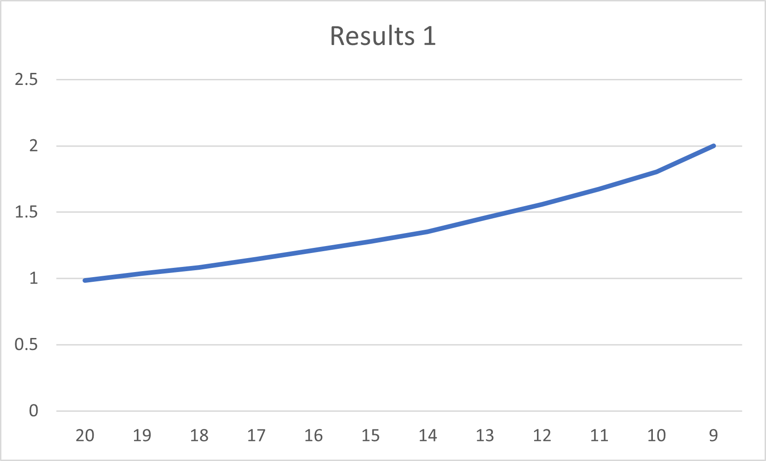

Results 2:

|  |  |  |  |
| --- | --- | --- | --- |
| # | Vsyringe mL | Psystem  atm | Psystem Vsyringe mL * atm |
| 1 | 20.0 | 0.986 | 20 * 0.986= 19.72 |
| 2 | 19.0 | 1.039 | 19 * 1.039= 19.741 |
| 3 | 18.0 | 1.093 | 18 * 1.093= 19.674 |
| 4 | 17.0 | 1.154 | 17 * 1.154= 19.618 |
| 5 | 16.0 | 1.215 | 16 * 1.215= 19.44 |
| 6 | 15.0 | 1.279 | 15 * 1.279= 19.185 |
| 7 | 14.0 | 1.351 | 14 * 1.351= 18.914 |
| 8 | 13.0 | 1.441 | 13 * 1.441= 18.733 |
| 9 | 12.0 | 1.548 | 12 * 1.548= 18.576 |
| 10 | 11.0 | 1.675 | 11 * 1.675= 18.425 |
| 11 | 10.0 | 1.825 | 10 * 1.825= 18.25 |
| 12 | 9.00 | 1.955 | 9 * 1.955= 17.595 |

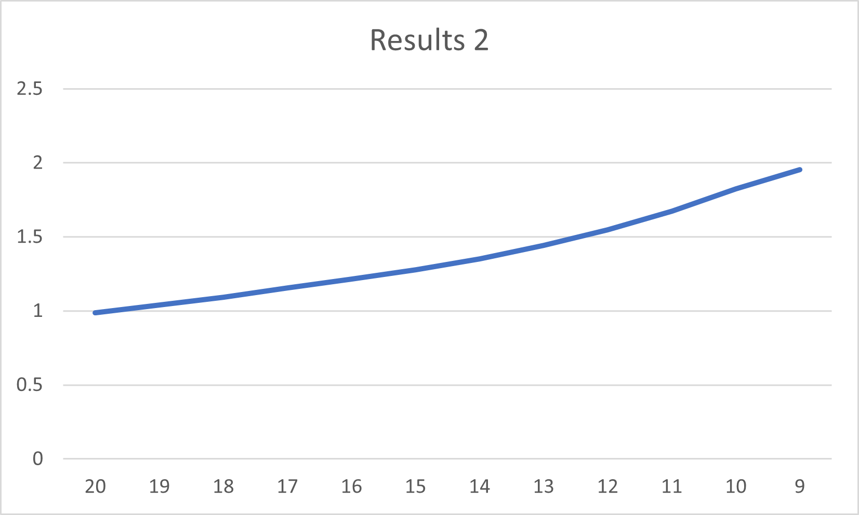

The graphs and charts above show that as volume decreases, pressure increases. This also proves that there is a relationship between pressure and volume, and that relationship is that as one increases, the other decreases, also known as an inverse relationship.

Conclusion:

In conclusion, Boyle’s Law stands true, in that, (if moles and temperature of the gas are held constant) as pressure increases, volume must decrease. The graphs show a slight curve in them due to human error, mainly that we were not precise enough in the measurement of the volume, resulting in a curve in our graph. We can now confidently saw with proof that pressure and volume have an inverse relationship.

Key Questions:

1. What will happen to the volume of the trapped air when the syringe plunger is depressed? - As the volume in the syringe decreases, the pressure inside should increase, and it should be harder for the volume to continually decrease over time due to the increasing pressure.
2. How are the pressure and volume of the air sample related based on the obtained results? - According to the results, the volume of the gas seems to decrease as the pressure increases, or they are inversely proportional to each other.
3. What does the mathematical term inversely related mean? - It means that as one goes down, the other goes up. A good example would be a seesaw, as one person goes down, the other goes up, and vice versa.
4. Allowing for small errors in making the measurements do the obtained data follow Boyle's law? Explain any discrepancy from Boyle's law. - The results generally follow Boyle's law, the changes in the constants (last column) end up quite large, but this was most likely because the volume we put most likely was not always precise, i.e., small changes in the volumes caused big changes down the line. This was purely our fault, and if we had repeated the experiment a few more times, we would have tried to precisely measure the volumes to get a similar constant for all the p * v.
5. How are Boyle's law (PV = k) and the ideal gas law (PV = nRT) related? - They are related because we did not change with the moles, the gas constant (we can’t do that anyway), or the temperature. This, in turn, makes them all constant, and when multiplied, they form k, the pressure volume constant.

